ST. XAVIER’S COLLEGE

**Maitighar, Kathmandu**

**(Affiliated to Tribhuvan University)**



**Database Management System**

**Lab Assignment #7**

**Submitted By**

Alok Shrestha

013BSCIT005

B.Sc. CSIT Year II/IV Semester

**Submitted To**

Er. Sanjay Kumar Yadav

Lecturer

Department of Computer Science

St. Xavier’s College

Maitighar, Kathmandu

**Submitted On**

September 2015

**Q1. List all employee names with their project name**

SELECT ename, pname from employee join work_in on employee.eno=work_in.eno

join projects on work_in.pno=projects.pno

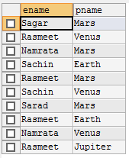

**Q2. List name of all employee and their salary who are working in project Mars or Venus**

SELECT distinct ename, salary from employee join work_in on employee.eno=work_in.eno

join projects on work_in.pno=projects.pno

where pname="Mars" or pname="Venus"

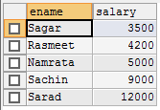

**Q3. List name of all employees and their salaries who are working in project Earth and Venus**

SELECT distinct ename, salary from employee join work_in on employee.eno=work_in.eno

join projects on work_in.pno=projects.pno

where pname="Earth" and pname="Venus"



**Q4. List name of all employees who work in department which is located in Pokhara**

SELECT distinct ename from employee

join department on employee.depno=department.depno

where location="Pokhara"

